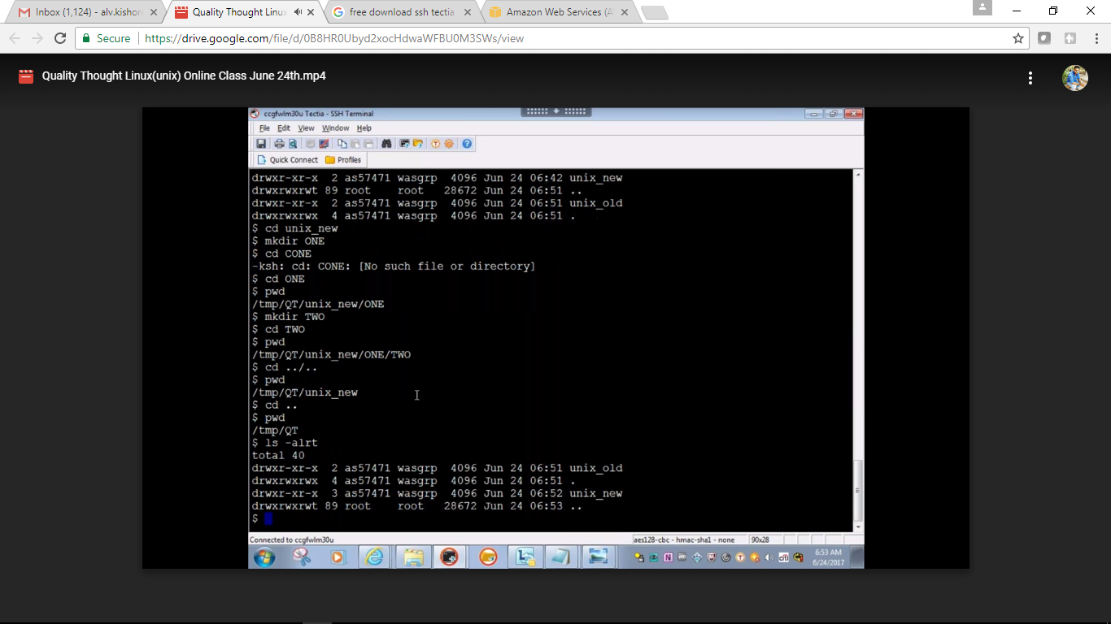

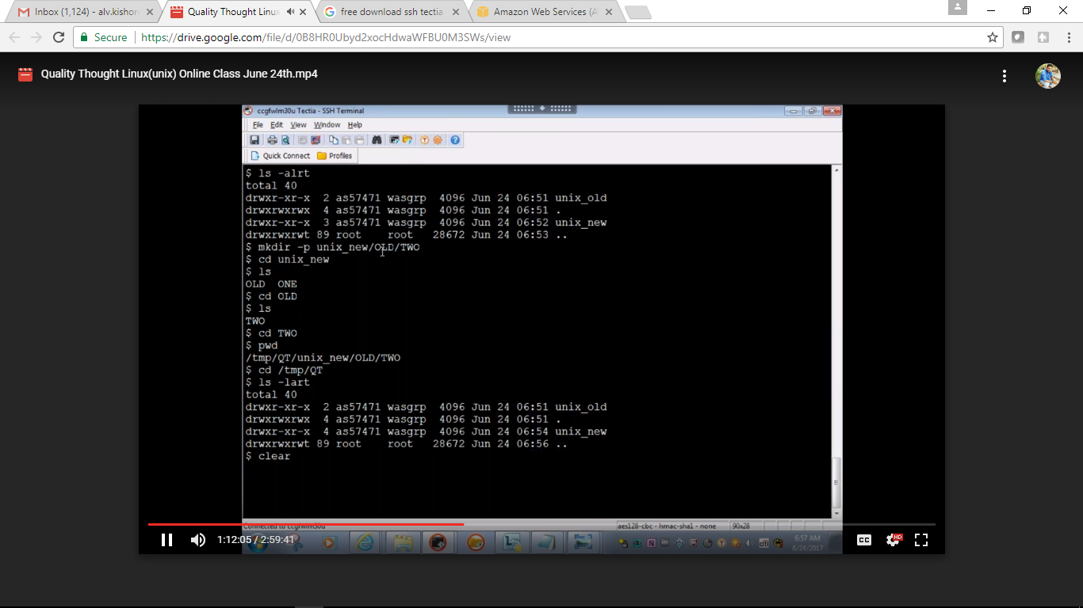

Redirection operator ‘>’

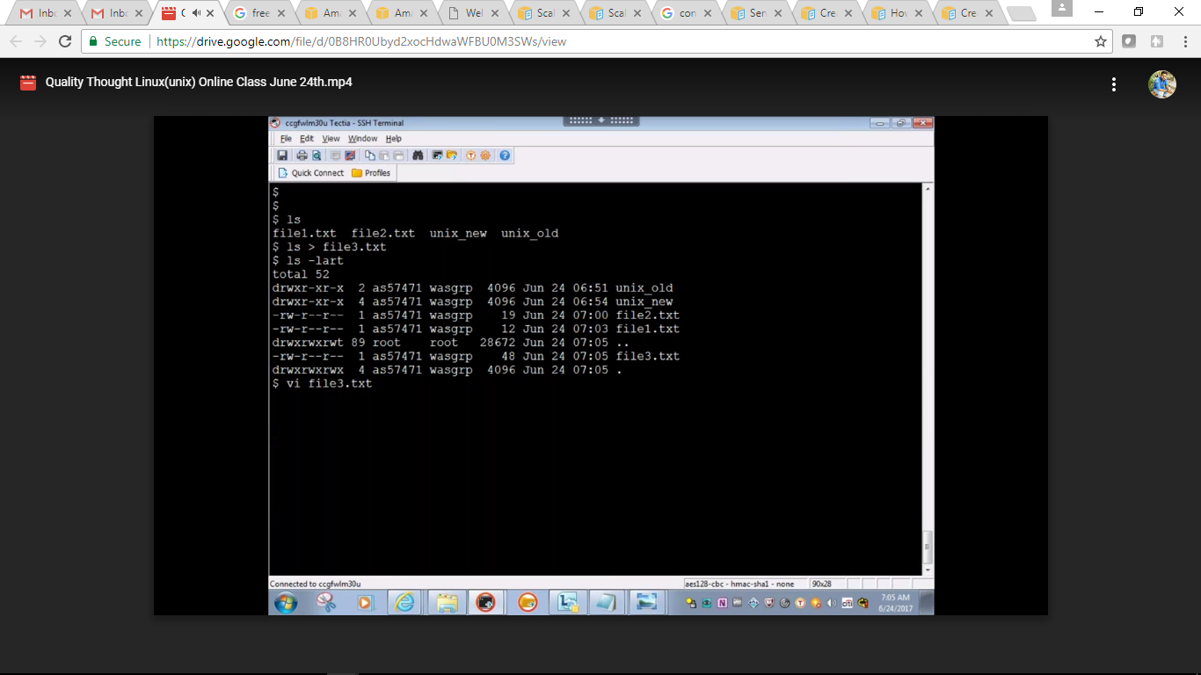

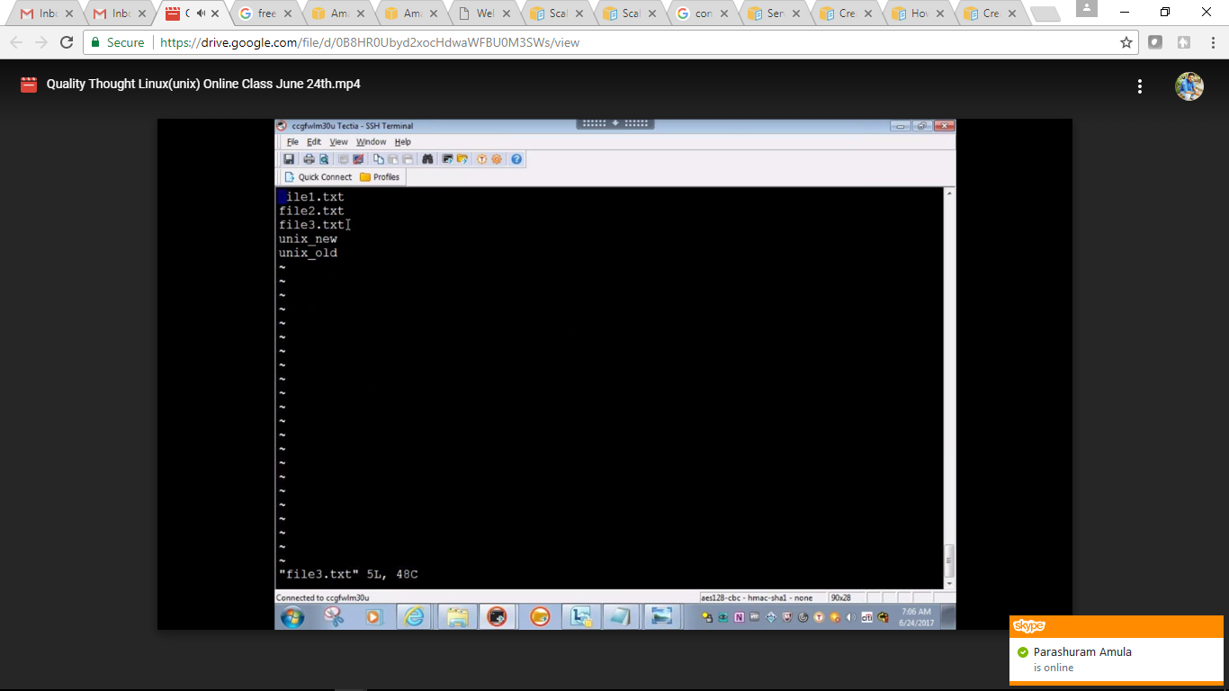

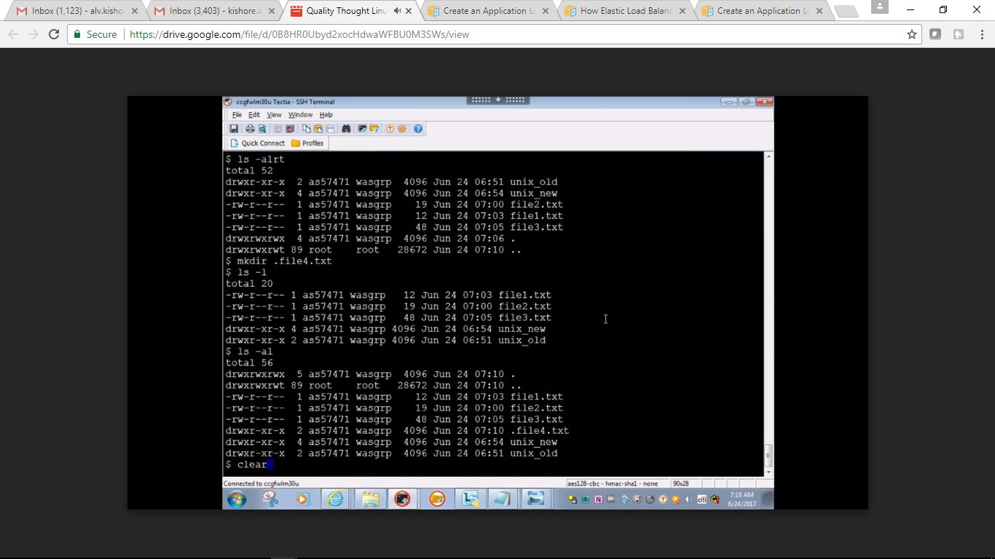

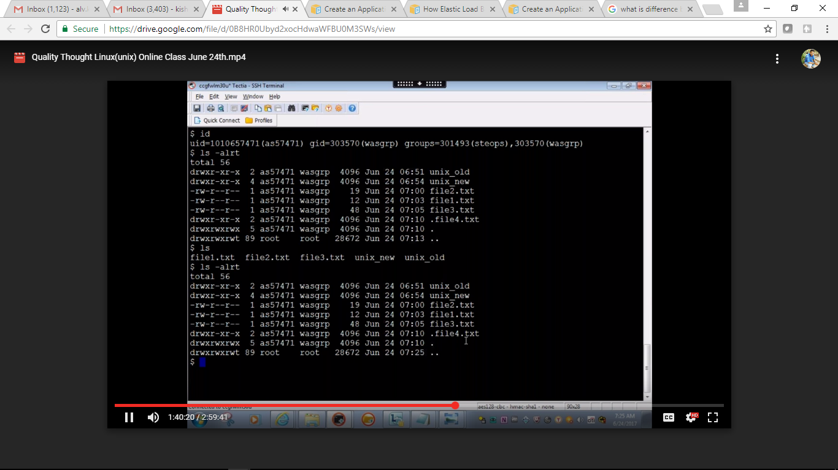

History command

File permission:

With chmod command you can give the permission / revoke the permission

Each member is one and we all belong to unix group

Ex: Other group devops , Hadoop

One user should belong to one group, if he want change the group then use chgrp

For each file /folder there are three permission are allowed

READ, write and execute: in a numeric format R means read permission will have 4 and write permission will have a 2 execute permission will have 1

Drwxrwxrwx : 1st three will be represents ur own permissions  
2nd rwx group permission  
3rd rwx belong to others groups

Change the persmission

Chmod

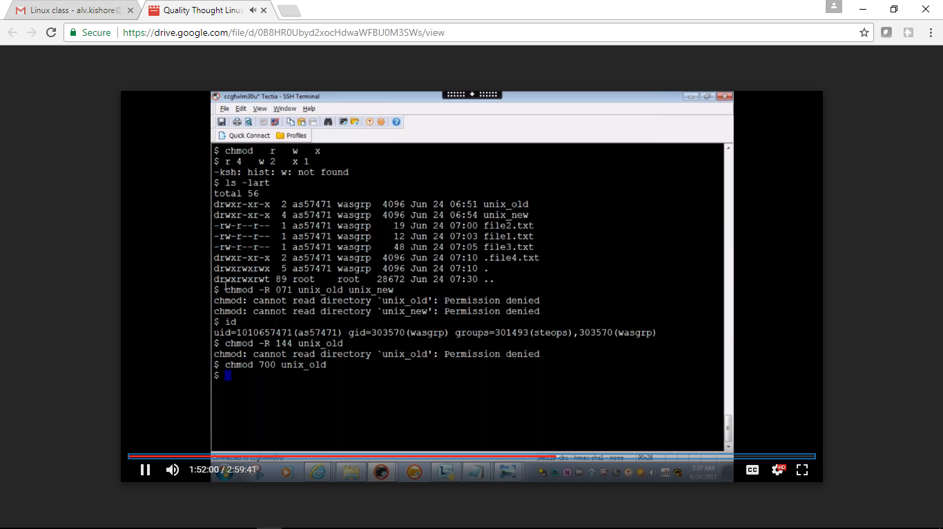

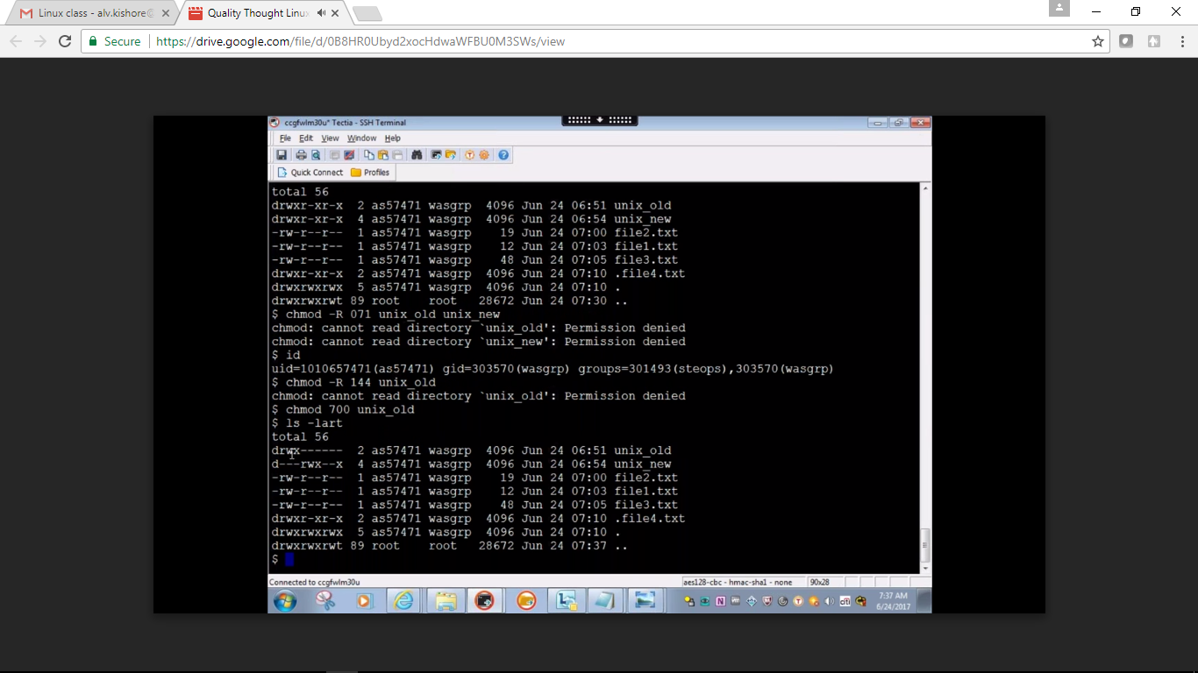

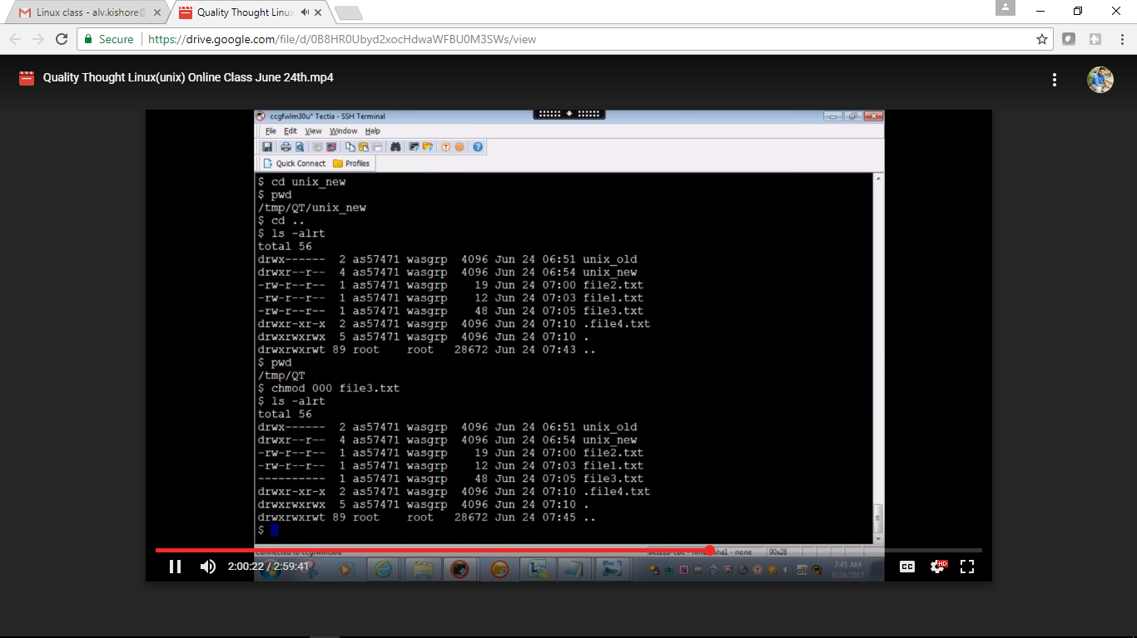

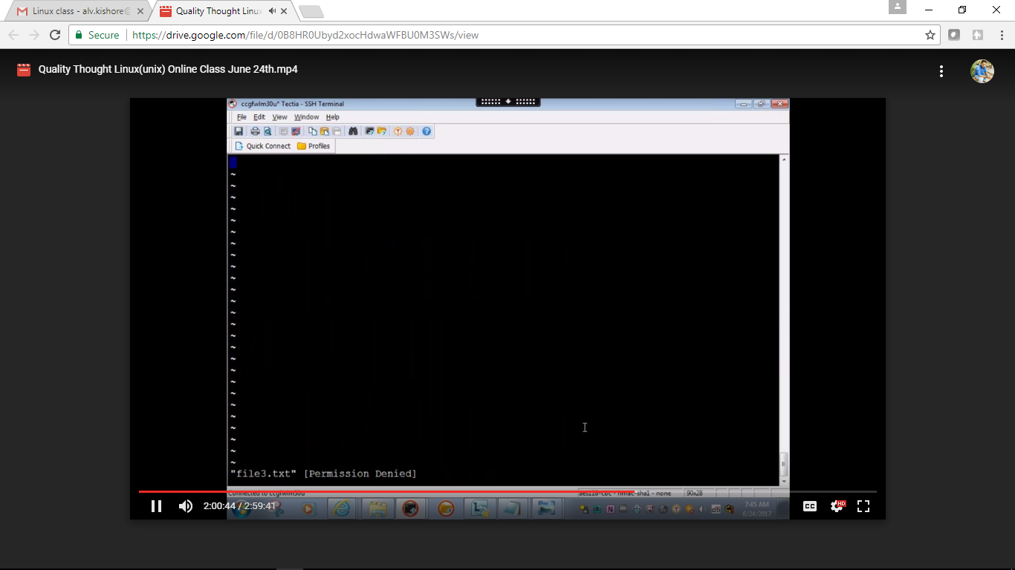

FILE view commands

Cat command: will give what ever the data in particular file it will print it and come out of that command  
\* everything or all

Less or more we cant come out unless we type ctrl+c

Head command will give first 10ines of the file

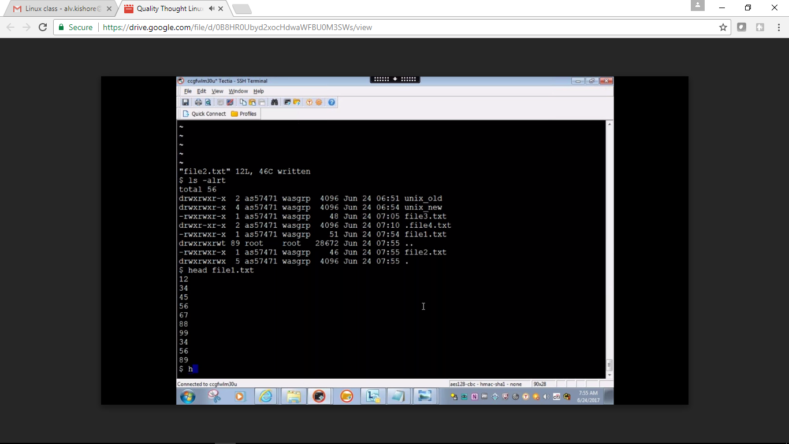

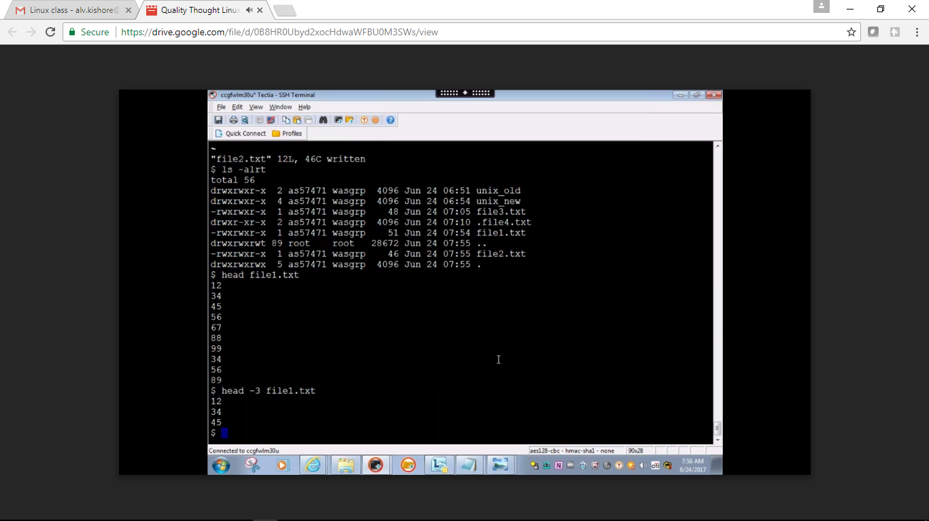

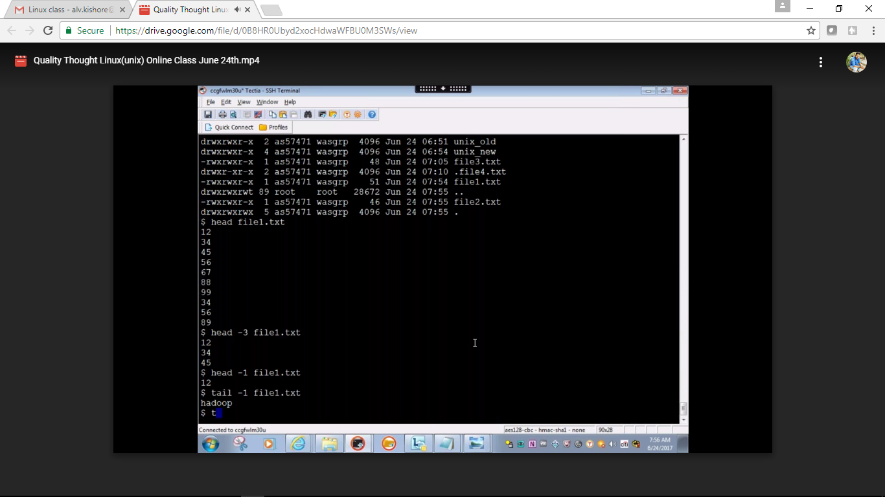

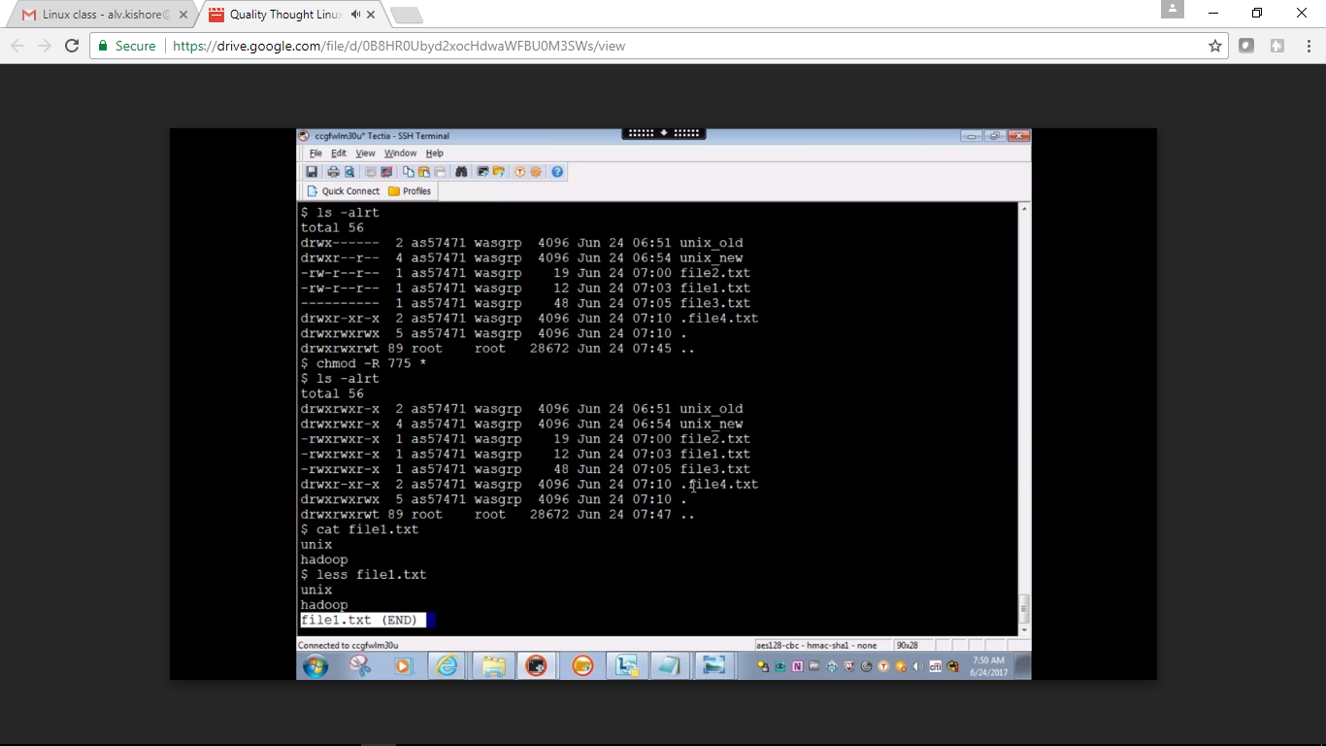

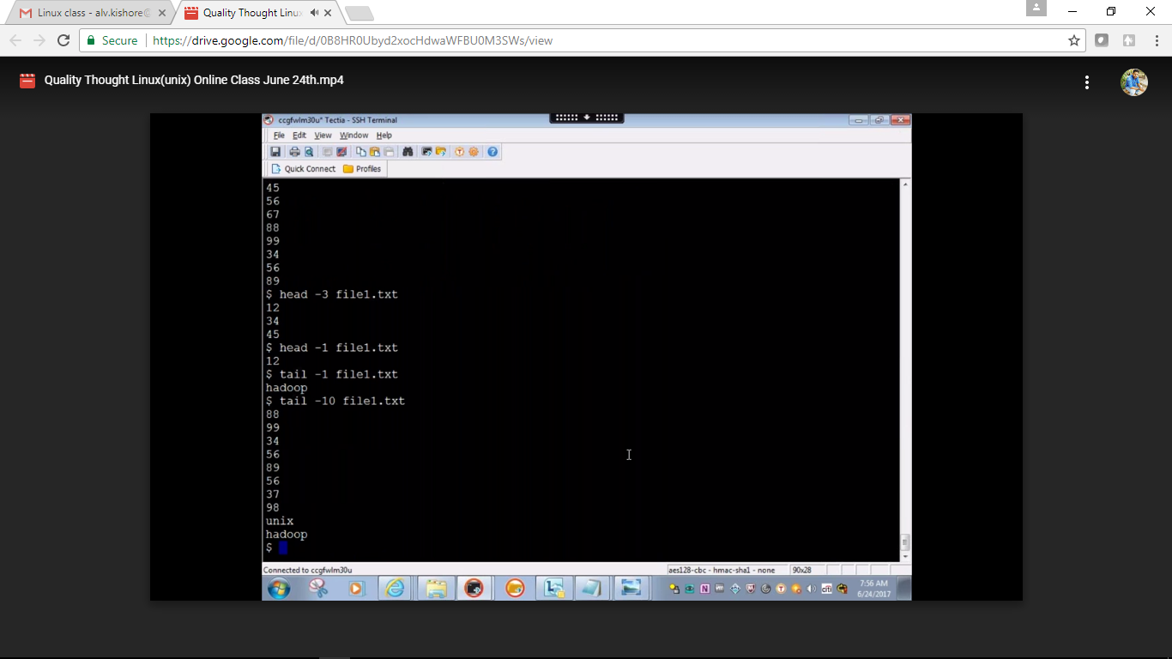

Tail command will give last lines of the file

Multiple commands in single shot

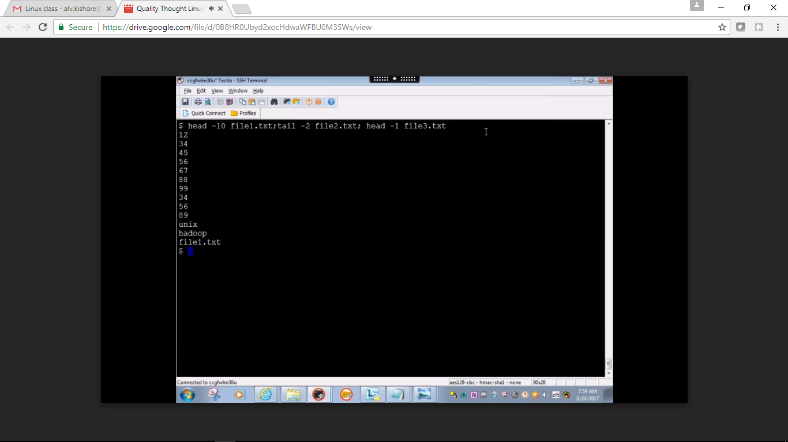

Pipe symbol

First command ouput will the inpout of second command

Comparrsion command: it will compare two files

Cmp file1.txt file2.txt

Diff command :

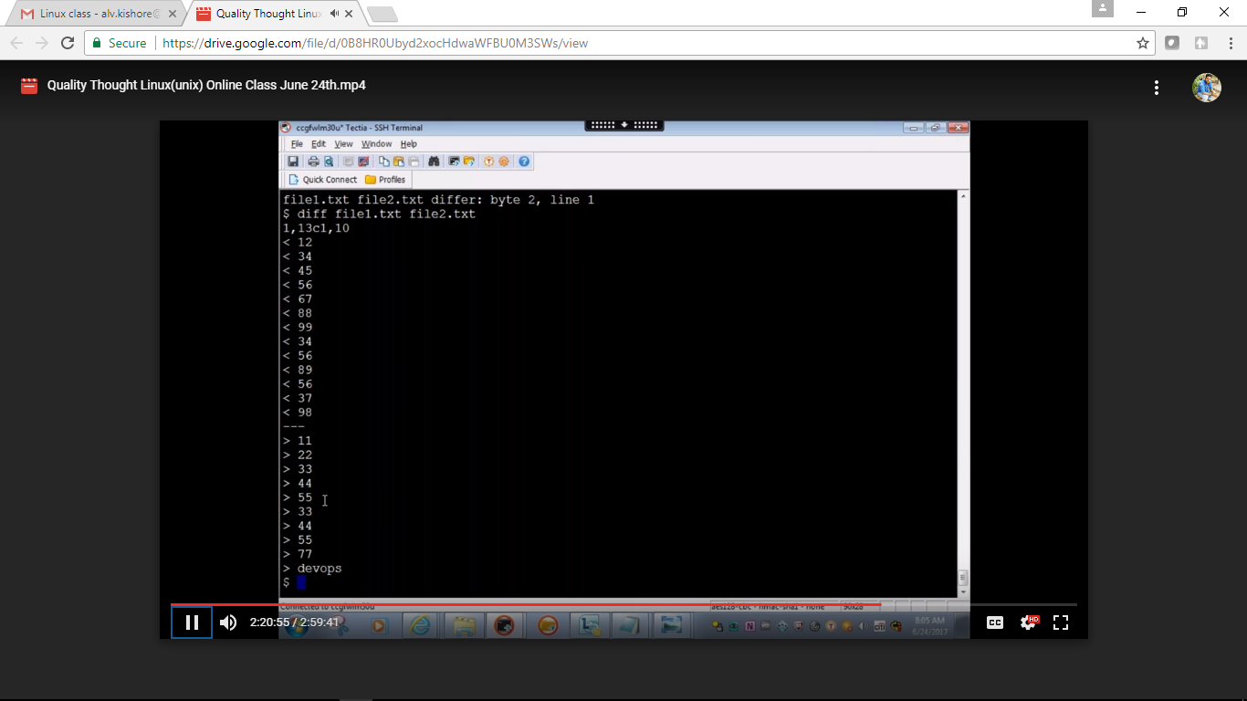

It will compare

System related commands:

How many people logged in: ‘who’ command  
who |wc –l  
wc –word count

System date: ‘date’ command

Who logged in: whoami

I want know which box I logged in: hostname

I want to know what type of machin this is : uname

Linux version

How many processors are there: uname –a

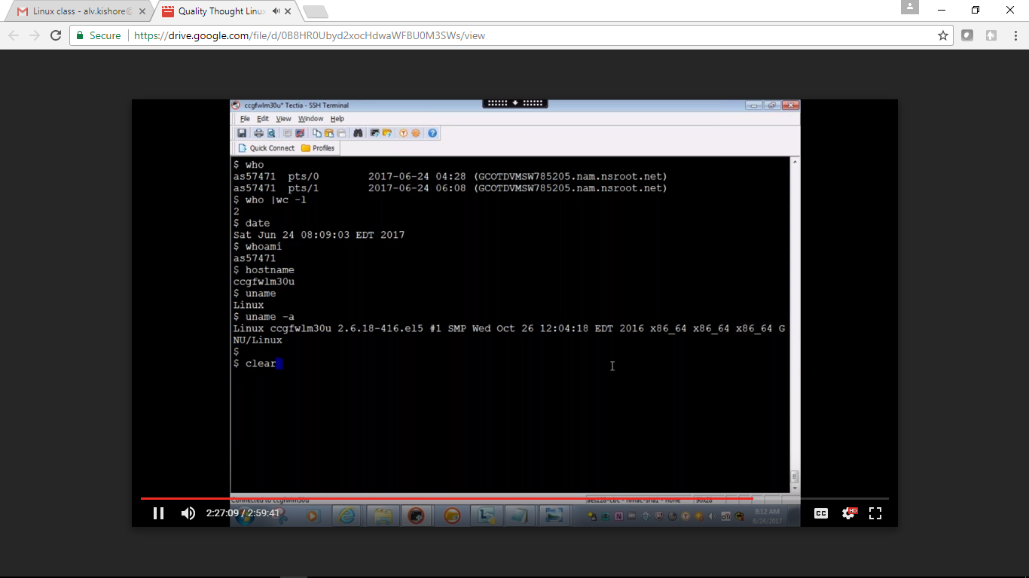

In unix first file it will execute is .profile

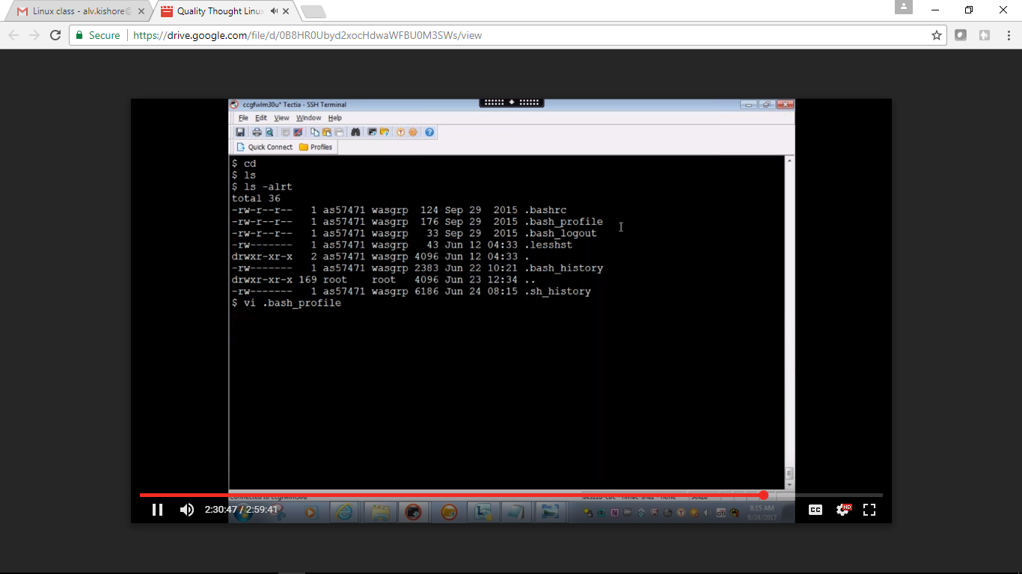

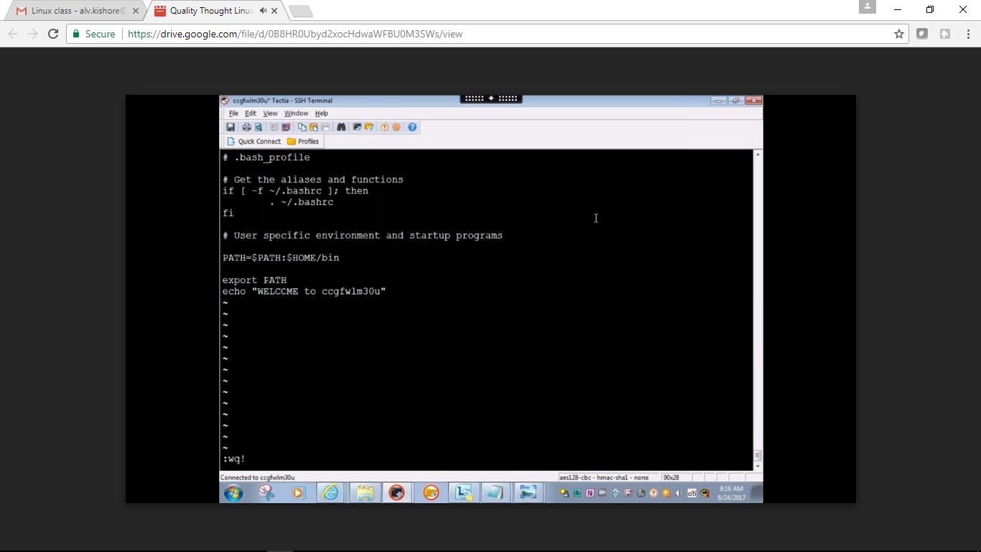

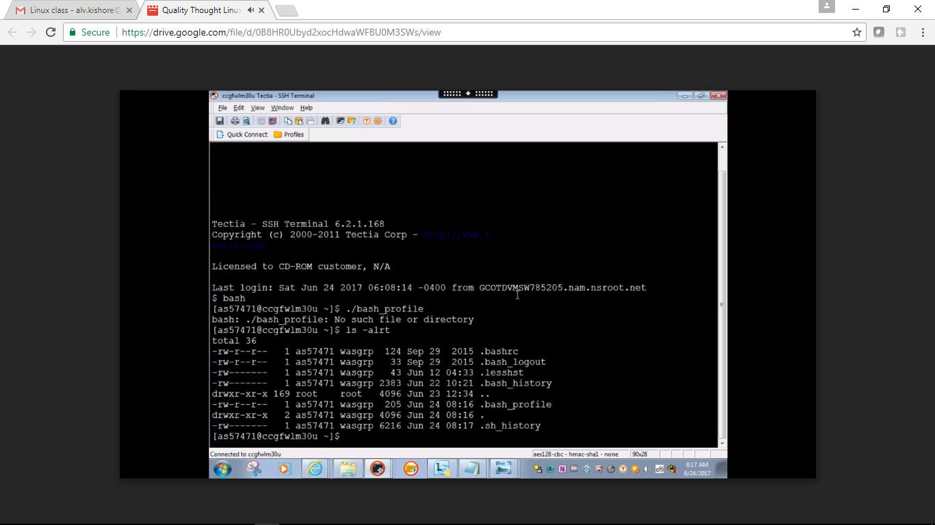

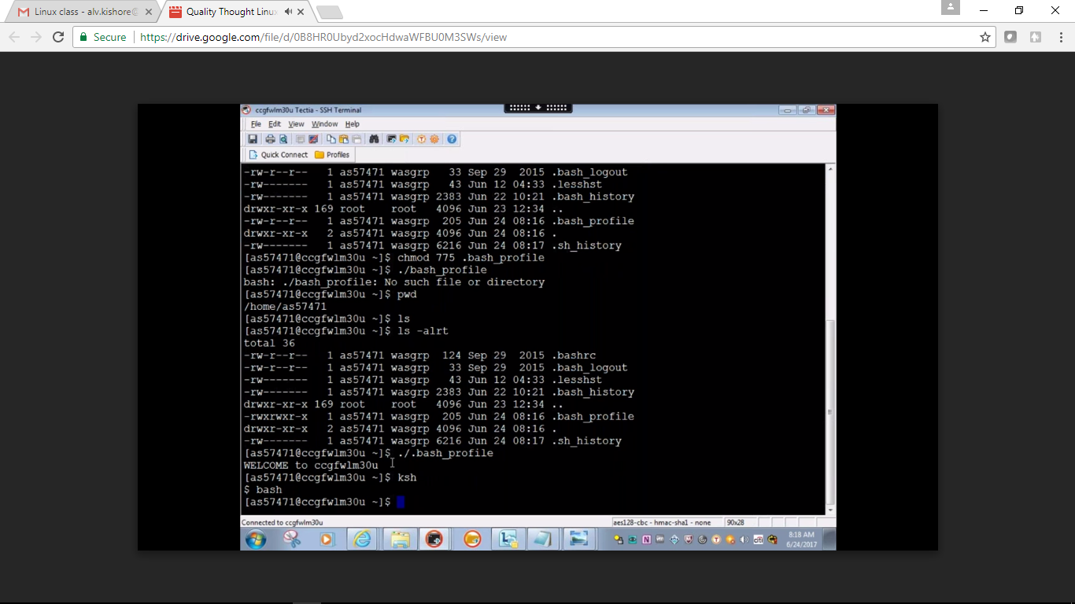

Passwd:

If unix host is rebooted then what is the first file to be execute etc/rc3.d this directoy will executre first , this will have all cron job

I want convert CD as only c what is the command to do that “alias”

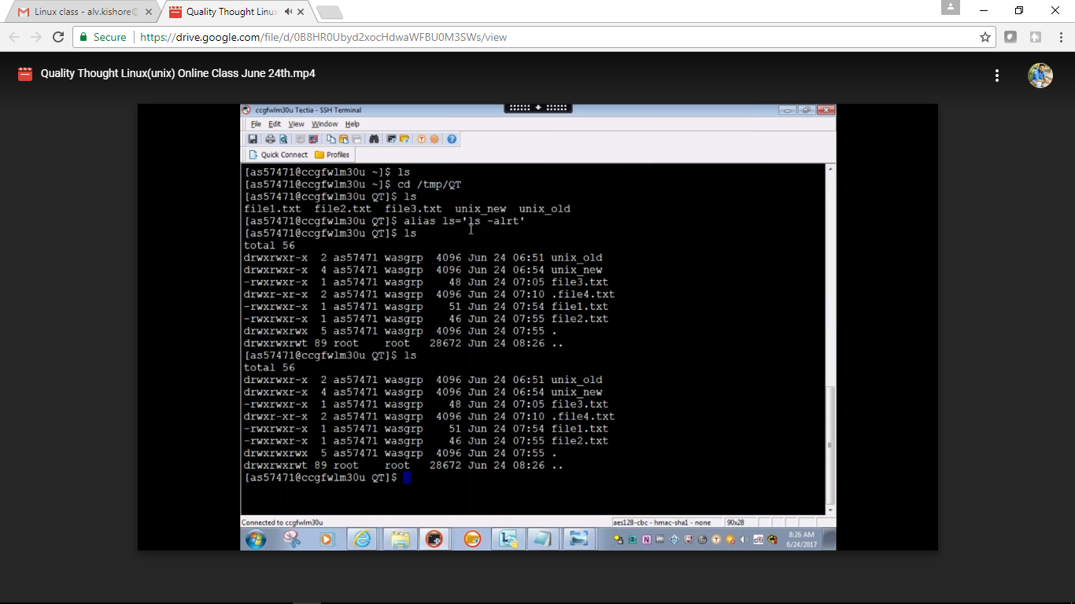

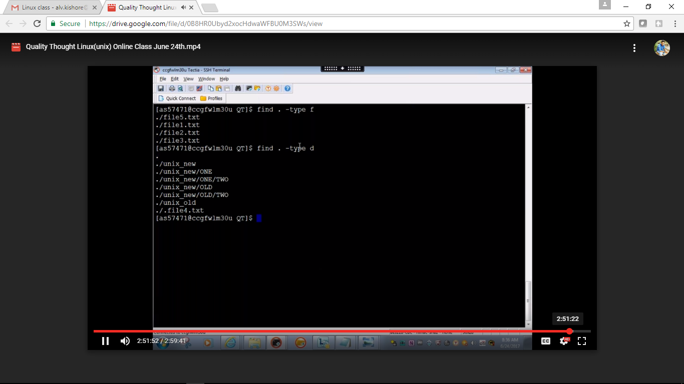

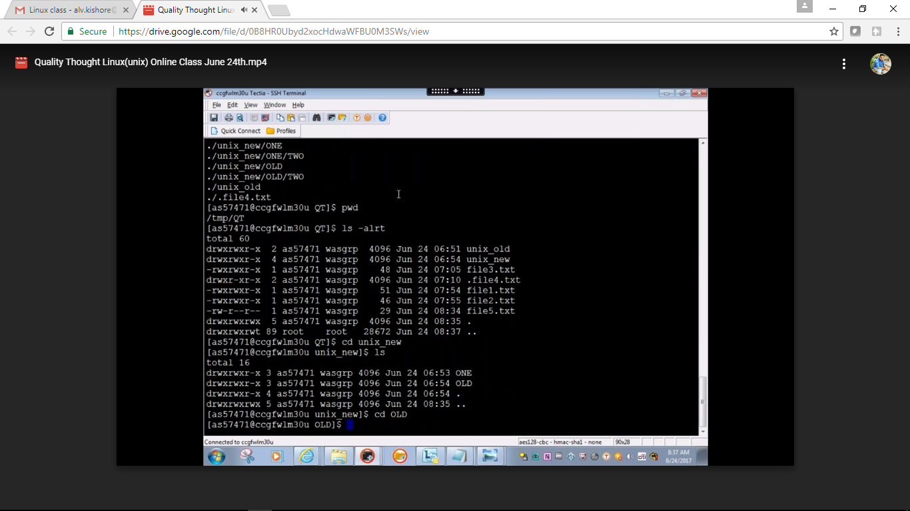

crontab -l -list

crontab -e - edit

/etc/crontab

d rwx-(user permission) ---(owner) ---otherusers

d -directory

r- read

w- write

x- execute

755

useradd command to add user

groupadd command to create group

sudo usermod -a -G fission kishore - to add user to the group

id kishore list of users and groups